Motherboard Chipsets and the Memory Map
I’m going to write a few posts about computer internals with the goal of explaining how modern kernels work. I hope to make them useful to enthusiasts and programmers who are interested in this stuff but don’t have experience with it. The focus is on Linux, Windows, and Intel processors. Internals are a hobby for me, I have written a fair bit of kernel-mode code but haven’t done so in a while. This first post describes the layout of modern Intel-based motherboards, how the CPU accesses memory and the system memory map.
我要写一些与现代内核如何工作相关计算机原理的文章。我希望对于热衷于这些却没有经验的程序员和爱好者有些帮助。文章主要关注linux, windows, 和 intel处理器。我对内部实现很感兴趣。第一篇文章介绍基于intel主板的现代布局，以及CPU如何访问内存和系统内存映射。
To start off let’s take a look at how an Intel computer is wired up nowadays. The diagram below shows the main components in a motherboard and dubious color taste:
开始旅行之前让我看看当今intel电脑是如何连接的。下图是主板的主要组件
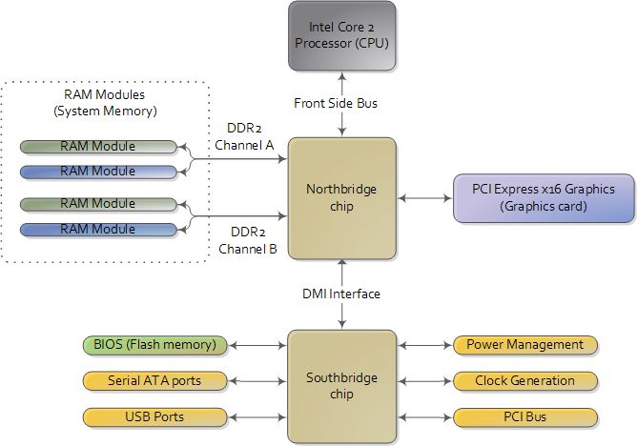
Diagram for modern motherboard. The northbridge and southbridge make up the chipset.
As you look at this, the crucial thing to keep in mind is that the CPU doesn’t really know anything about what it’s connected to. It talks to the outside world through its pins but it doesn’t care what that outside world is. It might be a motherboard in a computer but it could be a toaster, network router, brain implant, or CPU test bench. There are three main ways by which the CPU and the outside communicate: memory address space, I/O address space, and interrupts. We only worry about motherboards and memory for now.
现代主办的布局。北桥和南桥组成主板。正如你所看到的，最重要的事情是记住CPU并不知道有什么东西连接到它。它通过针脚与外界沟通，但是并不关心外界世界。它可能是一个带主板的计算机但也可能是个烤面包机，路由器。主要有三种方法来让cpu与外界通信：内存地址空间，I/O地址空间和中断。我们现在只关心主板和内存。
In a motherboard the CPU’s gateway to the world is the front-side bus connecting it to the northbridge. Whenever the CPU needs to read or write memory it does so via this bus. It uses some pins to transmit the physical memory address it wants to write or read, while other pins send the value to be written or receive the value being read. An Intel Core 2 QX6600 has 33 pins to transmit the physical memory address (so there are 2³³ choices of memory locations) and 64 pins to send or receive data (so data is transmitted in a 64-bit data path, or 8-byte chunks). This allows the CPU to physically address 64 gigabytes of memory (2³³ locations * 8 bytes) although most chipsets only handle up to 8 gigs of RAM.
Now comes the rub. We’re used to thinking of memory only in terms of RAM, the stuff programs read from and write to all the time. And indeed most of the memory requests from the processor are routed to RAM modules by the northbridge. But not all of them. Physical memory addresses are also used for communication with assorted devices on the motherboard (this communication is called memory-mapped I/O). These devices include video cards, most PCI cards (say, a scanner or SCSI card), and also the flash memory that stores the BIOS.
在主板中CPU通向世界的大门是前端总线，来连接到北桥。它使用一些针脚传输想要读写的物理内存地址，其他的针脚用来发送读写的数值。Intel Core 2QX6600试用33个针脚来传输屋里内存地址（所以这里有2^33个内存位置）。64个针脚用来发送和读取（数据是被64bit数据传输，或者8字节数据块）。这允许cpu屋里寻址64gb的内存。虽然大部分主板仅能支持8gb内存。我们所认为的内存仅仅用ram表示，程序都在对其读写。cpu的内存请求通过北桥路由到ram模块。物理内存地址也用来与各种设备通信。（这种通讯被叫做memory I/O）这些设备包括显卡，pci设备和bios的flash存储。
When the northbridge receives a physical memory request it decides where to route it: should it go to RAM? Video card maybe? This routing is decided via the memory address map. For each region of physical memory addresses, the memory map knows the device that owns that region. The bulk of the addresses are mapped to RAM, but when they aren’t the memory map tells the chipset which device should service requests for those addresses. This mapping of memory addresses away from RAM modules causes the classic hole in PC memory between 640KB and 1MB. A bigger hole arises when memory addresses are reserved for video cards and PCI devices. This is why 32-bit OSes have problems using 4 gigs of RAM. In Linux the file /proc/iomem neatly lists these address range mappings. The diagram below shows a typical memory map for the first 4 gigs of physical memory addresses in an Intel PC:
当北桥接受到一个物理内存请求，它决定了如何路由：是该去内存？显卡？路由是通过内存地址映射。对于每个物理内存地址区域，内存映射都知道设备所属区域。绝大部分分配给内存，但是他们不是内存映射告诉主板那些设备为这些地址服务。内存地址映射远离RAM模块，引起传统的PC内存空洞，位于640kb到1mb之间。更大内存空洞为pci和显卡表留。这就是为什么32位操作系统有使用4gb内存的问题。在linux /proc/iomem 列出了内存地址映射。下图列出了一个典型的intelpc的4gb内存映射
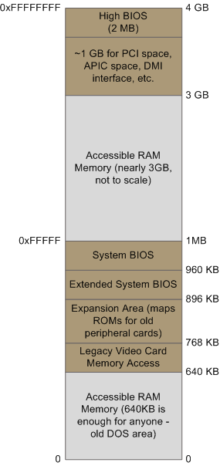
Memory layout for the first 4 gigabytes in an Intel system.
Actual addresses and ranges depend on the specific motherboard and devices present in the computer, but most Core 2 systems are pretty close to the above. All of the brown regions are mapped away from RAM. Remember that these are physical addresses that are used on the motherboard buses. Inside the CPU (for example, in the programs we run and write), the memory addresses are logical and they must be translated by the CPU into a physical address before memory is accessed on the bus.
实际地址和范围依赖于主板规格和计算机中的设备，但是core2大多和上图类似。褐色被从内存中隔离。记住这些物理内存通过主板总线使用。在cpu内部（例如，在程序中读写），内存地址是逻辑的它们必须在总线访问之前被cpu翻译成物理地址。
The rules for translation of logical addresses into physical addresses are complex and they depend on the mode in which the CPU is running (real mode, 32-bit protected mode, and 64-bit protected mode). Regardless of the translation mechanism, the CPU mode determines how much physical memory can be accessed. For example, if the CPU is running in 32-bit mode, then it is only capable of physically addressing 4 GB (well, there is an exception called physical address extension, but ignore it for now).
翻译逻辑地址为屋里地址的规则很复杂，他们依赖于cpu运行于什么模式（实模式，32位保护模式，64位保护模式）。无论如何翻译机制，cpu模式决定有多少内存。例如，如果cpu运行于32位内存，则仅有4gb物理内存。
Since the top 1 GB or so of physical addresses are mapped to motherboard devices the CPU can effectively use only ~3 GB of RAM (sometimes less - I have a Vista machine where only 2.4 GB are usable). If the CPU is in real mode, then it can only address 1 megabyte of physical RAM (this is the only mode early Intel processors were capable of). On the other hand, a CPU running in 64-bit mode can physically access 64GB (few chipsets support that much RAM though). In 64-bit mode it is possible to use physical addresses above the total RAM in the system to access the RAM regions that correspond to physical addresses stolen by motherboard devices. This is called reclaiming memory and it’s done with help from the chipset.
因为顶端的1gb，物理内存地址被映射到主板设备，cpu仅能有效使用3gb内存。如果cpu位于实模式，仅能使用1mb的物理内存。换句话说，cpu运行于64位貌似哦嘿，可以访问64gb内存。在64位模式中尽可能的使用所有内存访问内存区域
That’s all the memory we need for the next post, which describes the boot process from power up until the boot loader is about to jump into the kernel. If you’d like to learn more about this stuff, I highly recommend the Intel manuals. I’m big into primary sources overall, but the Intel manuals in particular are well written and accurate. Here are some:
- Datasheet for Intel G35 Chipset documents a representative chipset for Core 2 processors. This is the main source for this post.
- Datasheet for Intel Core 2 Quad-Core Q6000 Sequence is a processor datasheet. It documents each pin in the processor (there aren’t that many actually, and after you group them there’s really not a lot to it). Fascinating stuff, though some bits are arcane.
- The Intel Software Developer’s Manuals are outstanding. Far from arcane, they explain beautifully all sorts of things about the architecture. Volumes 1 and 3A have the good stuff (don’t be put off by the name, the “volumes” are small and you can read selectively).
- Pádraig Brady suggested that I link to Ulrich Drepper’s excellent paper on memory. It’s great stuff. I was waiting to link to it in a post about memory, but the more the merrier.

